Create Development Machine in Azure

# Why

* Experiment with technologies we don’t desire to or can’t install locally.
* Set up a Virtual Machine for teaching and clone it for students.

# Steps

1. With your MSDN Subscription, log into the New Azure Portal.
   * portal.azure.com
   * You’ll need to enable your MSDN Azure subscription or create a “Pay as you go” subscription. Then wait for the subscription service to be activated before continuing.
2. Select the “New” button in the bottom left.



1. Select “Compute”
   * You’ll see several options from “Windows Server 2012 R2” to “Cloud Service”.
   * These options are available to all Azure users.
2. Select “Azure Marketplace” at the bottom.

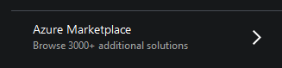

* + These aren’t free images. The image we are going to select requires an MSDN license.

1. In the “Search Everything” dialog type “Visual Studio”.

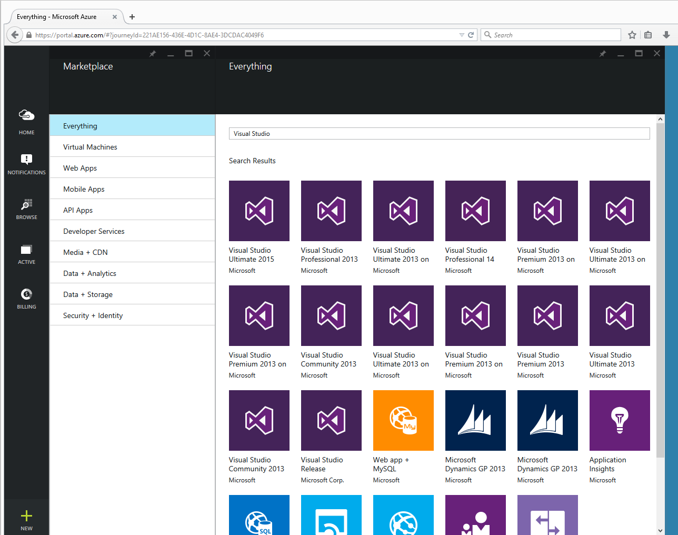

1. Select “Visual Studio Ultimate 2015”.
   * A window will open to the right describing the selected option.
2. Select “Create”.
3. You’ll be asked for the machine name and a userID and password
   * Don’t forget your user ID and password.
4. Press Create.

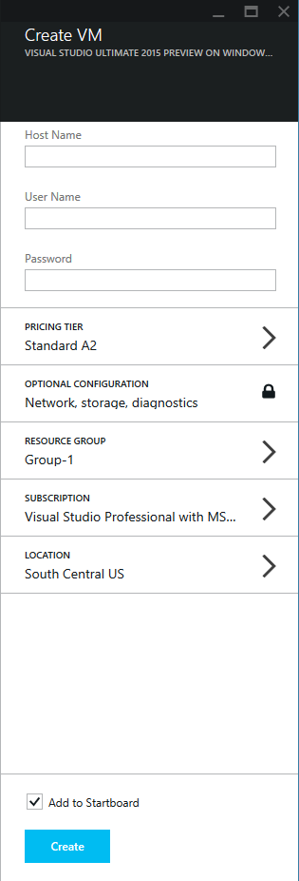

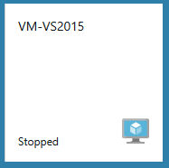

# Additional Resources

If you got this far you might as well check these videos out and see what else is possible.

### Windows Azure Pack **Infrastructure as a Service**, Service Management Automation

<https://www.youtube.com/watch?v=NL11EtTZrhk\>

### The World’s Greatest Azure Demo **(PaaS)** (spends time talking about Azure from a developer’s perspective)

<https://www.youtube.com/watch?v=7V8HikBP1vQ>

### Modern Web Development Tools in Visual Studio 2015

<https://www.youtube.com/watch?v=YFg-SbgITdY>

### Explore Visual Studio Online

<https://www.youtube.com/watch?v=MNrXvv21_jE>